63rd SPC and 93rd DGINS CONFERENCE
BUDAPEST, 19–21 September 2007

HOTEL RESERVATION FORM
Individual guest
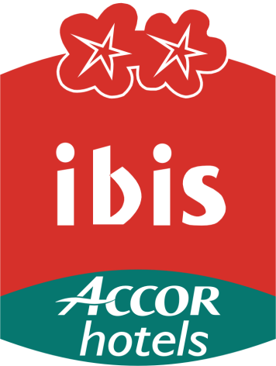
ibis Budapest Centrum
Please make the following hotel reservation completing it in BLOCK CAPITALS and return by fax or e-mail no later than 19 July 2007 directly to:
ibis Budapest Centrum  Reservation  Ráday utca. 6  H–1092 Budapest  Tel: +36 1 456 4100  Fax: +36 1 456 4116  E-mail: h2078@accor.com | SPECIAL CONFERENCE RATE PER NIGHT  (Breakfast, taxes and service included)
 | BEDROOM TYPE | SINGLE |  | DOUBLE
 | Standard Room | 85 Euro □ |  | 93 Euro □
 | Non-smoking room □ |  | Smoking room □
 | Special rates are valid from 18 to 23 September 2007
Date of arrival: Sept. 2007 Hour: Date of departure: Sept. 2007 Hour:
Family name: First name:
Title: Organisation:
Street:
Zip: City: Country:
Telephone: + Fax: +
E-mail:
Accompanied by (name):
Remarks/special request:
Reservation guaranteed by my credit card:
□ Master/Eurocard □ American Express □ Visa □ Diners
Cardholder name:
Card number: Expiry date:

Please note:
- To take advantage of these rates, please use ONLY this reservation form.
- The deadline date for reservations is 19 July 2007.
- After 19 July 2007 the hotel reserves the right to confirm the booking upon the availability of the rooms.
- Check in time is 14:00H/Check out 12:00H

Cancellations Policy:
I guarantee this room reservation with my credit card. I agree that in case of non-arrival, the first night’s room rate will be charged to my credit card, unless the reservation has been cancelled and the cancellation confirmed by fax 72 hours before the arrival date.
Date: Signature/authorization:

